UI-
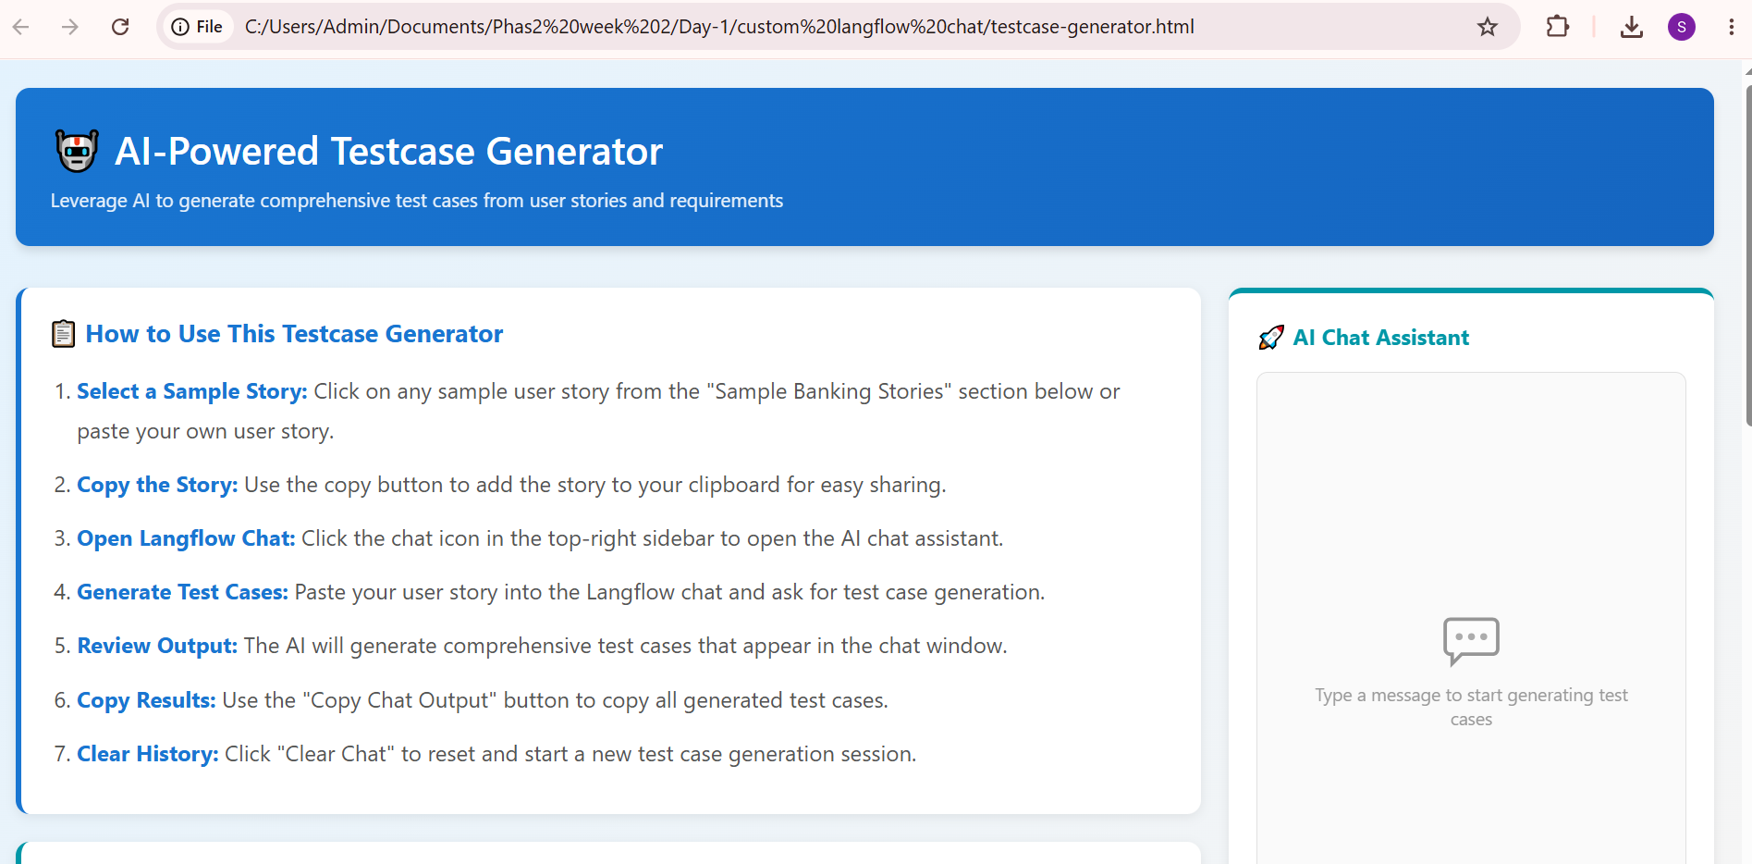

Copy a story-
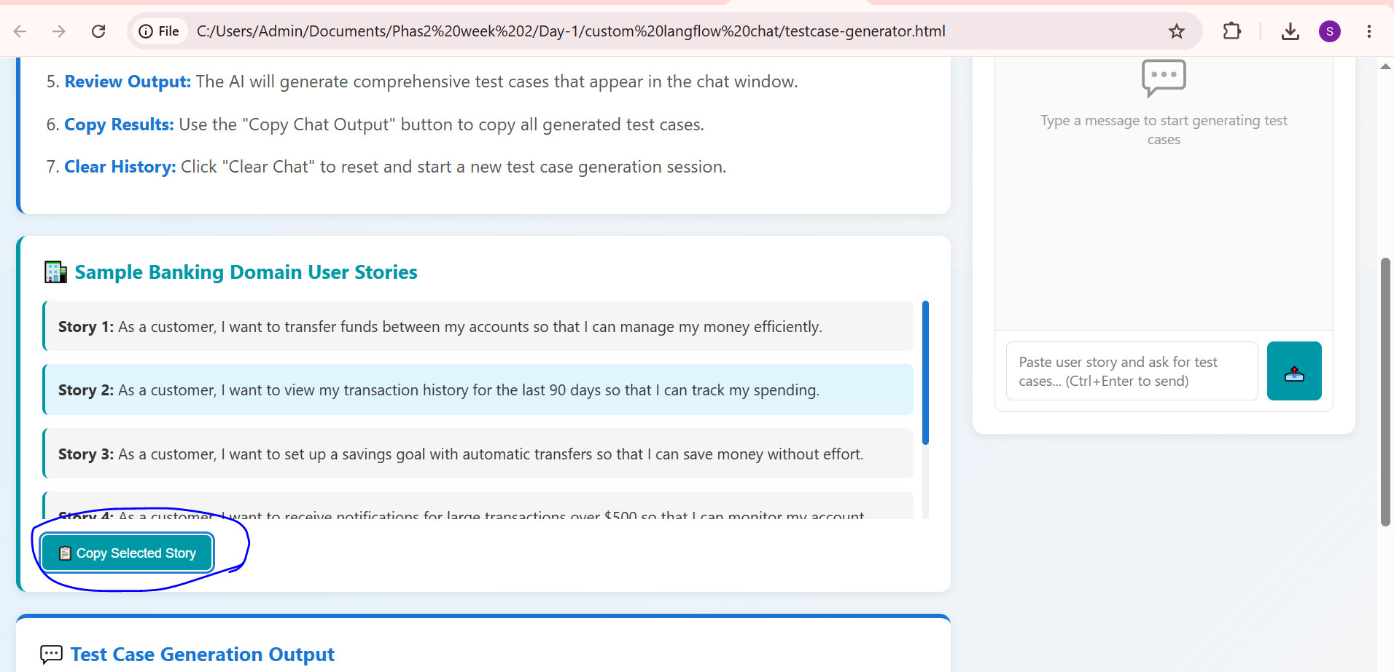

Output :
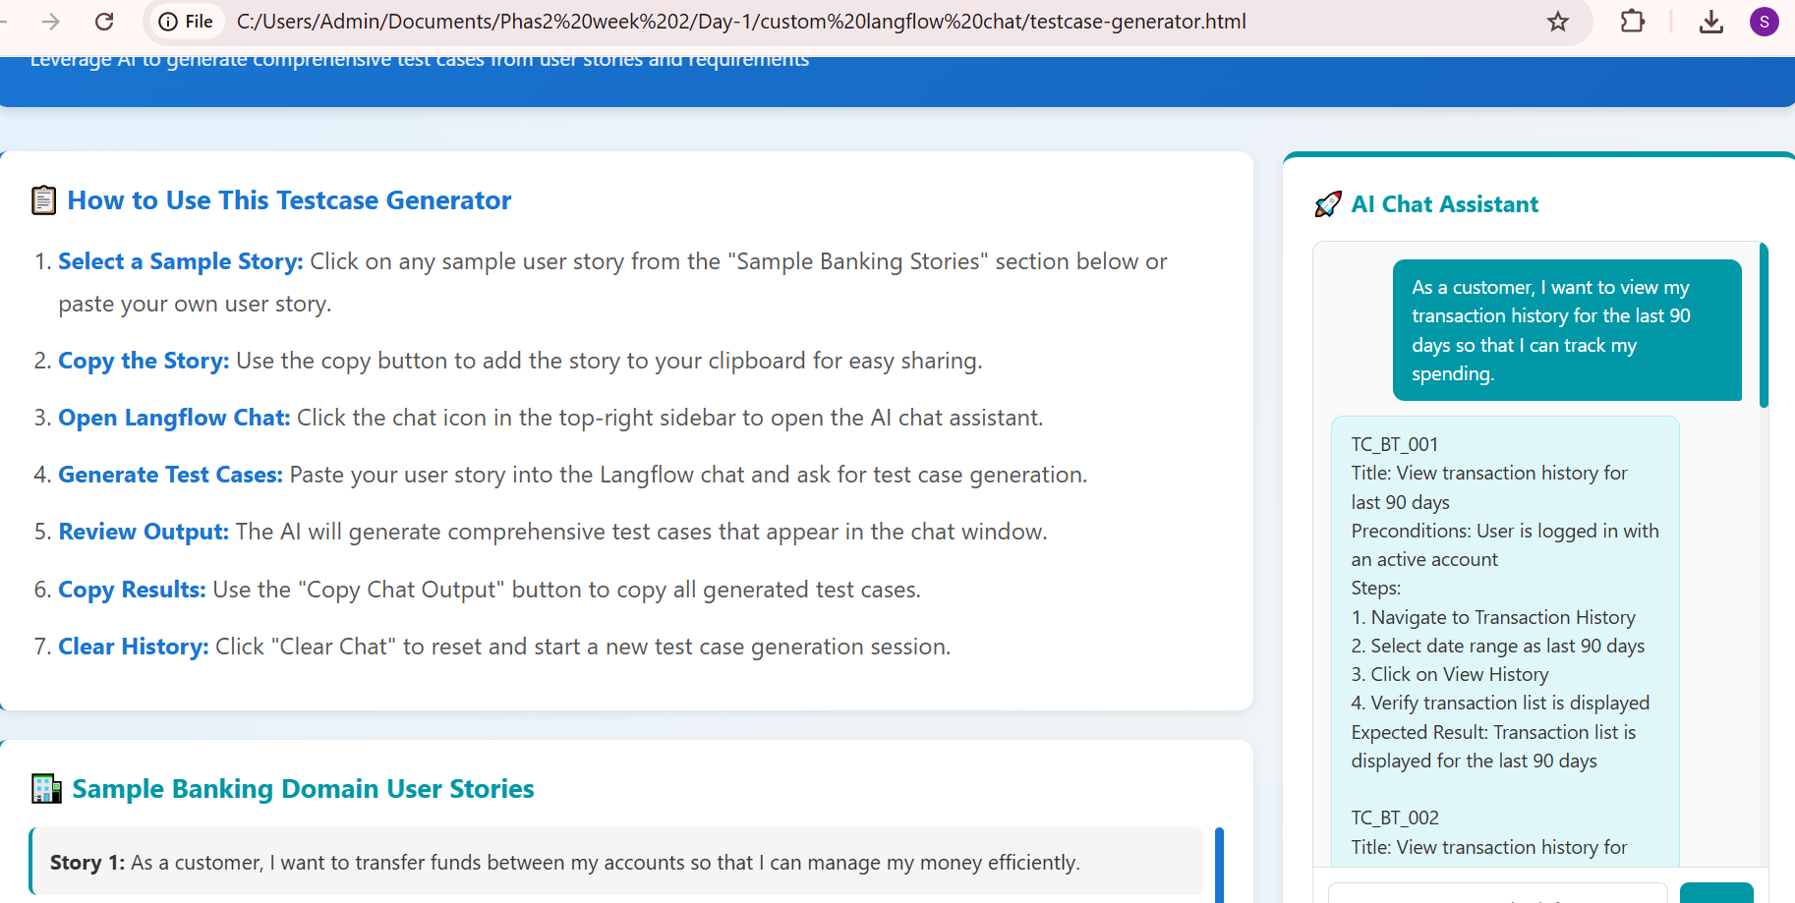

Output:
TC_BT_001 Title: View transaction history for last 90 days Preconditions: User is logged in with an active account Steps: 1. Navigate to Transaction History 2. Select date range as last 90 days 3. Click on View History 4. Verify transaction list is displayed Expected Result: Transaction list is displayed for the last 90 days TC_BT_002 Title: View transaction history for invalid date range Preconditions: User is logged in with an active account Steps: 1. Navigate to Transaction History 2. Select date range as invalid dates (e.g., 01-01-2020 to 01-01-2010) 3. Click on View History 4. Verify error message is displayed Expected Result: Error message is displayed indicating invalid date range TC_BT_003 Title: View transaction history with no transactions Preconditions: User is logged in with an active account and has no transactions Steps: 1. Navigate to Transaction History 2. Select date range as last 90 days 3. Click on View History 4. Verify no transactions are displayed Expected Result: No transactions are displayed TC_BT_004 Title: View transaction history with pagination Preconditions: User is logged in with an active account and has multiple transactions Steps: 1. Navigate to Transaction History 2. Select date range as last 90 days 3. Click on View History 4. Verify pagination is displayed with multiple pages Expected Result: Pagination is displayed with multiple pages TC_BT_005 Title: View transaction history with filter applied Preconditions: User is logged in with an active account and has multiple transactions Steps: 1. Navigate to Transaction History 2. Select date range as last 90 days 3. Apply filter (e.g., by transaction type) 4. Click on View History 5. Verify filtered transactions are displayed Expected Result: Filtered transactions are displayed

